**Game Environment Ideas - Videos**

1. [**Outlanders**](https://www.youtube.com/watch?v=OsIINve6QWc)

- Awesome music, vibes, graphics, colour schemes

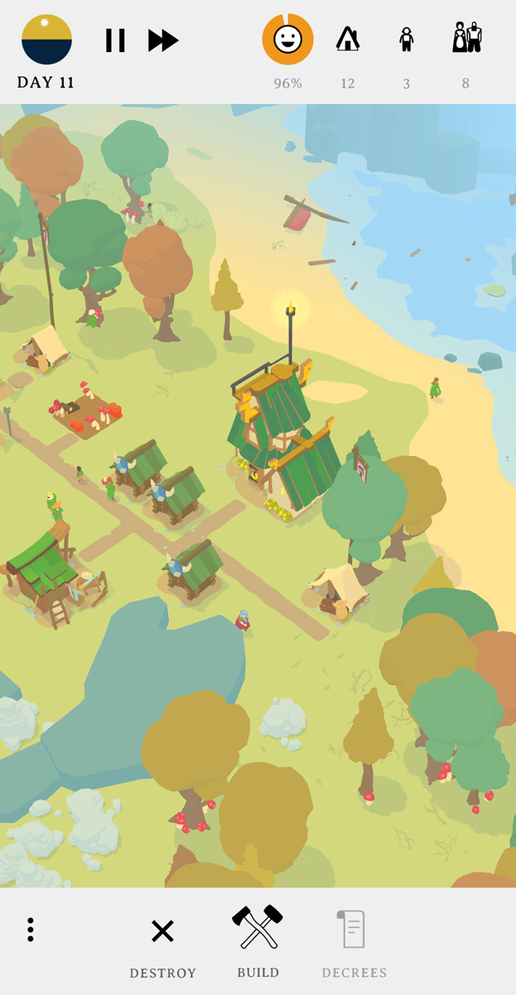 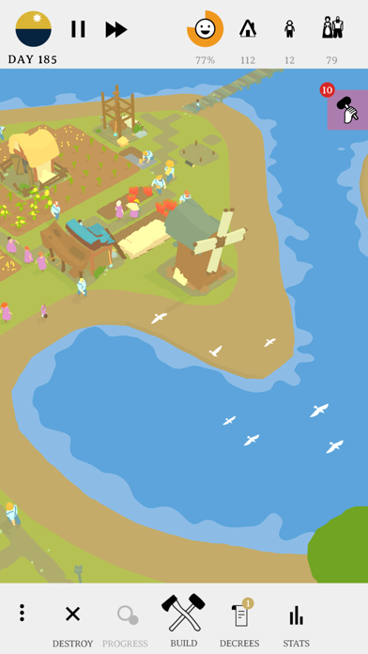

1. [**The Enchanted Wood**](https://www.youtube.com/watch?v=5wzueIhyOcY)

- Love the transformation from broken to nice with the magic

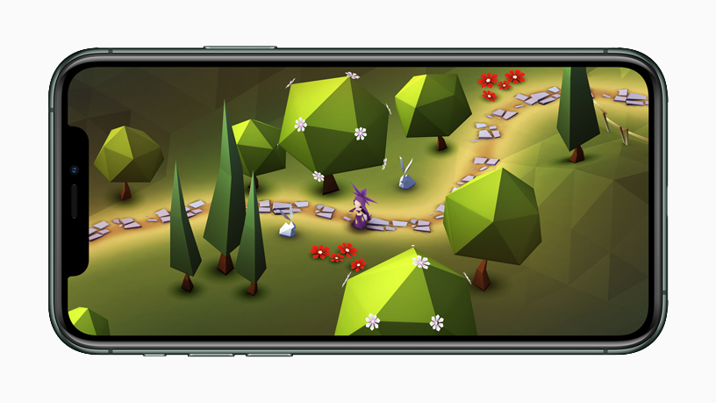

1. [**Knight’s Retreat**](https://www.youtube.com/watch?v=54ibEGIER-4)

- Can take the idea of the switching between areas/ maps

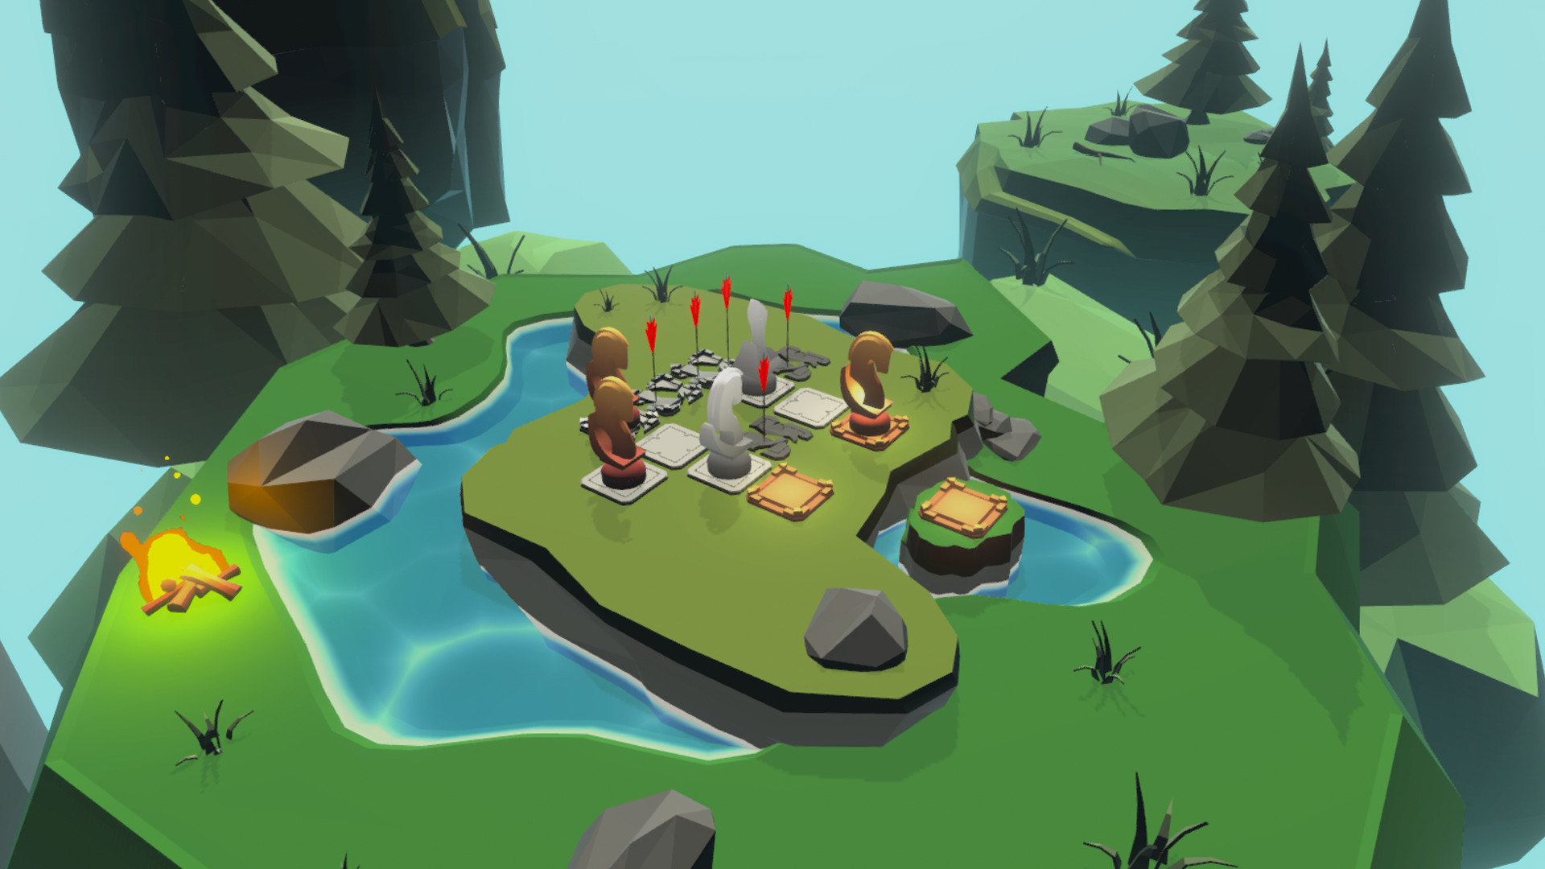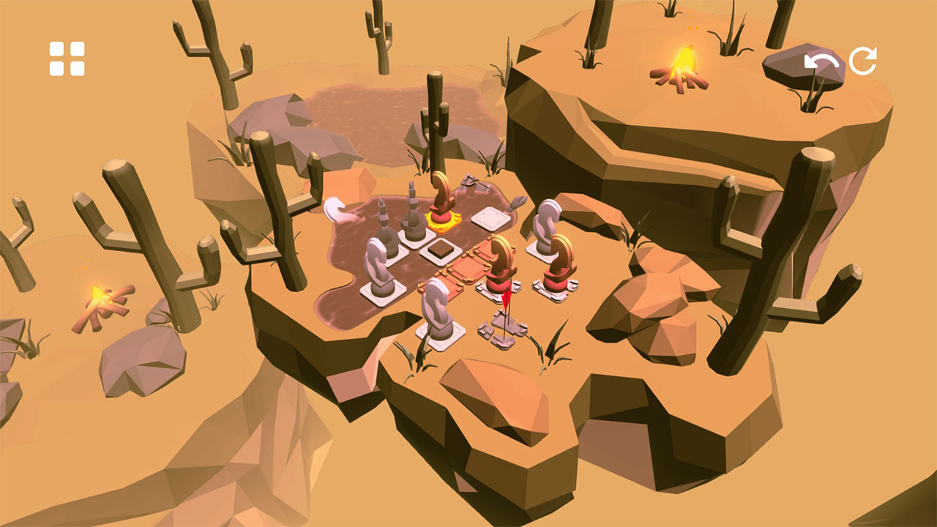

1. [**Islanders**](https://www.youtube.com/watch?v=nnDWm9dpu3o)

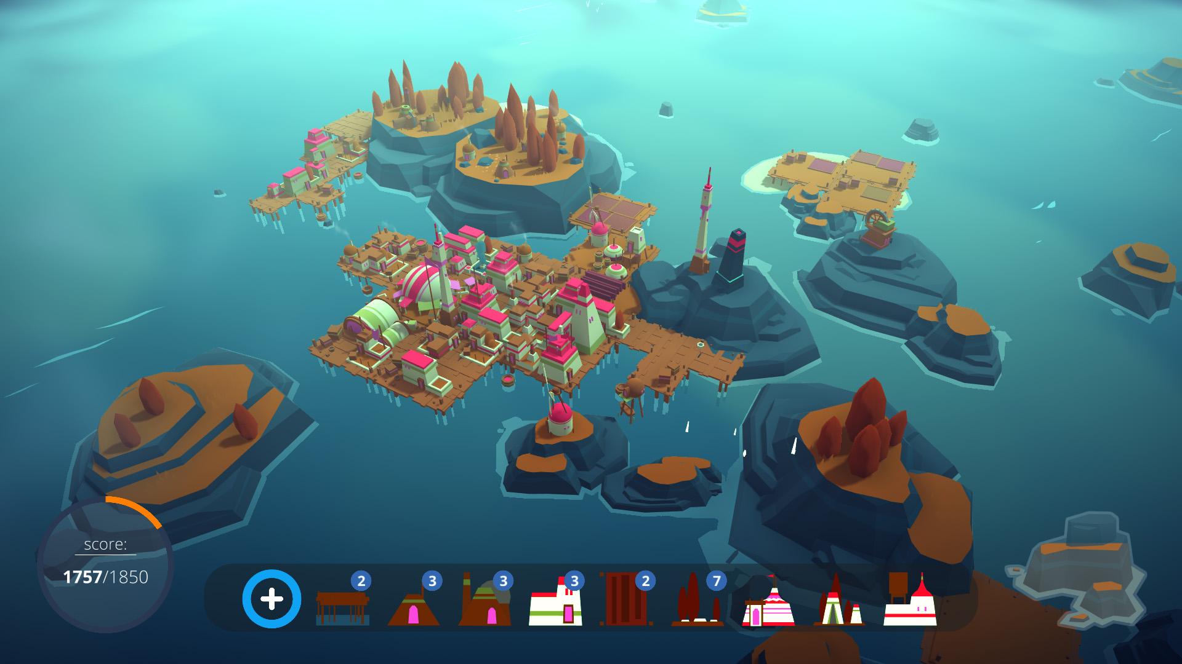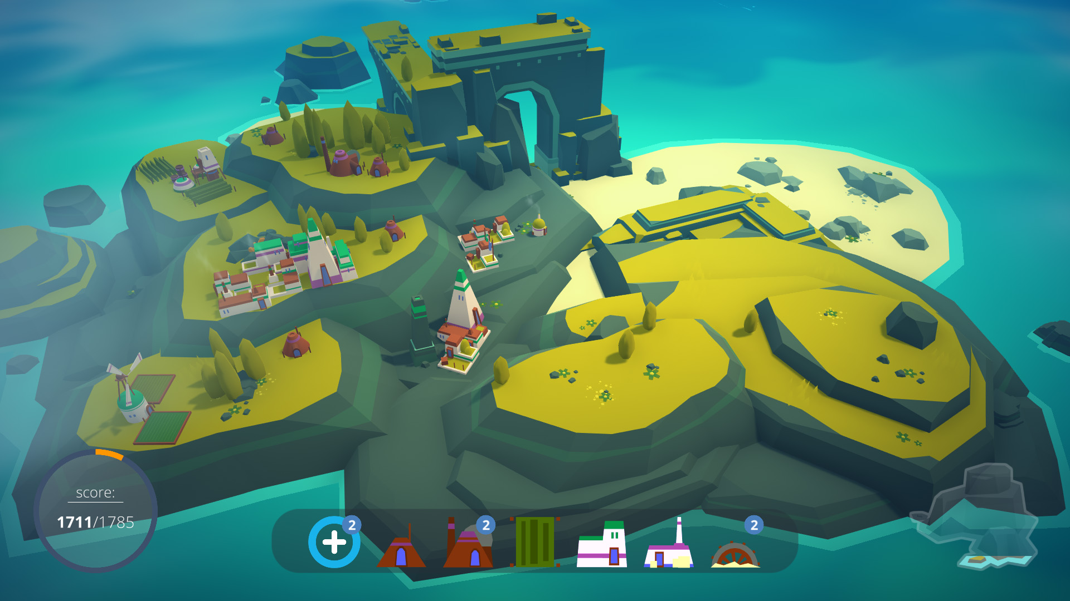

- Love the squarish builds and map

1. [**Monument Valley**](https://www.youtube.com/watch?v=E3437orz_4E)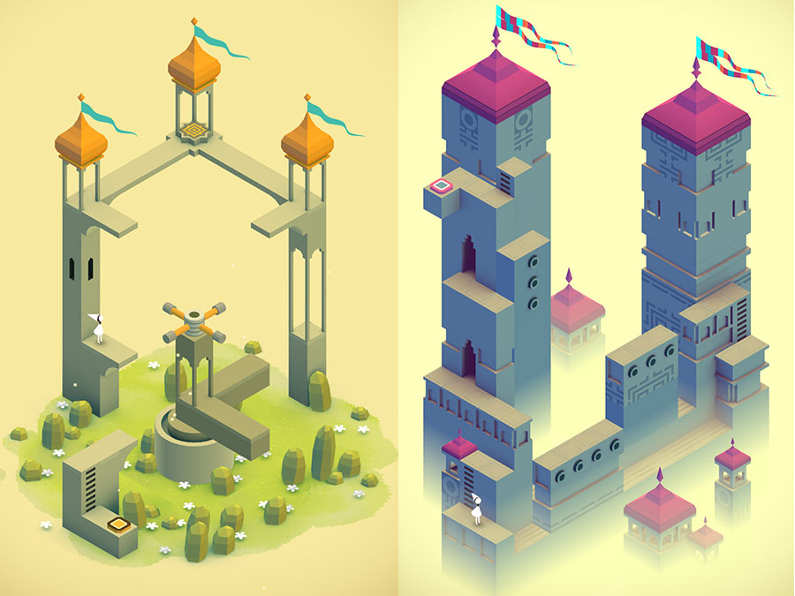

- Overall vibes chill and zen